Design:

The automation code below is run using an HTML design file. Adobe InDesign was used as software to create basis design which was then exported as an .idml and .html package including assets and variable fields denoted. The .idml and a PDF file were used as reference to create the final HTML version for use in automation instructions below.

USFS Automation

* Runs in Visual Studio 2019
* May need to install Chrome Driver on machine.

First need to set up directories in code:

* Put root folder “pdf508” on drive.
* In the code set the path for folder “template_508”

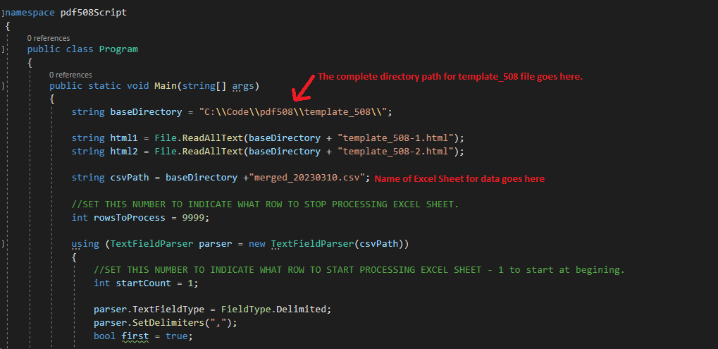

folder “template_508” should look like this:   
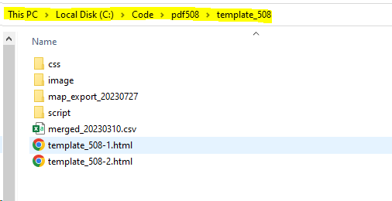

Prepare ExcelSheet:

* Need to move column “PDF Name” to column “b”

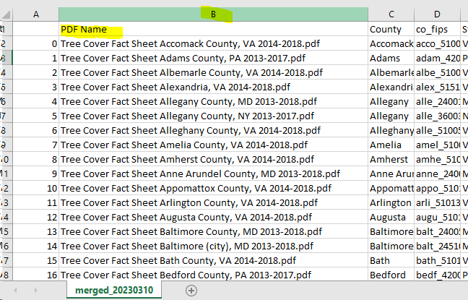

Need to add new column named: “ConditionalCounty”

It is a copy of countycityCamel column but with values for city empty.

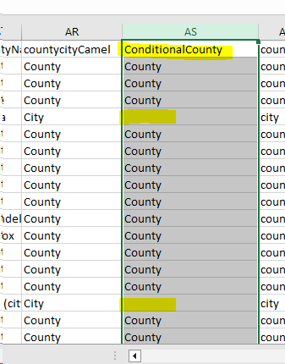

Run Program.   
Program flow is as follows:  
1) It will Create 2 html files, 1 for each page.

2) Then it will created 2 pdf files, 1 for each page.

3) Merge the 2 pdfs to one doc   
4) Delete the html files created and the 2 pdfs created in step 2.   
5) It will move on to next record

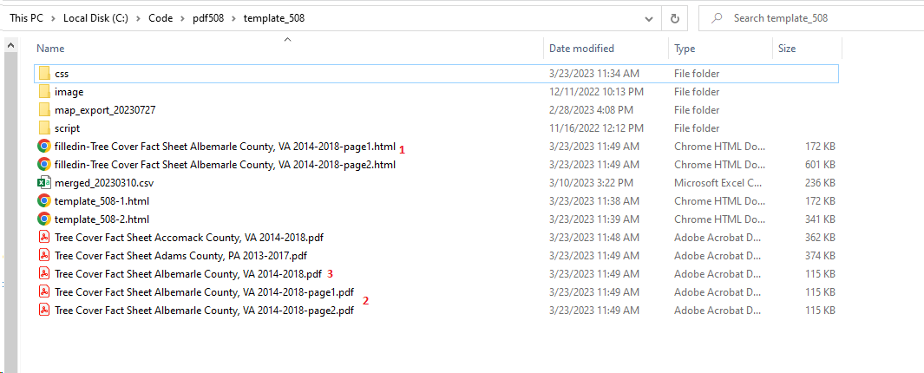

Final file generated is as follows:

